**Microsoft Fabric with Medallion Architecture (Bronze-Silver-Gold)**

1. **Created e-commerce bronze layer**

1. **Created Lakehouse in the bronze layer**

1. **Uploading csv files to Lakehouse**

1. Files are present in Lakehouse

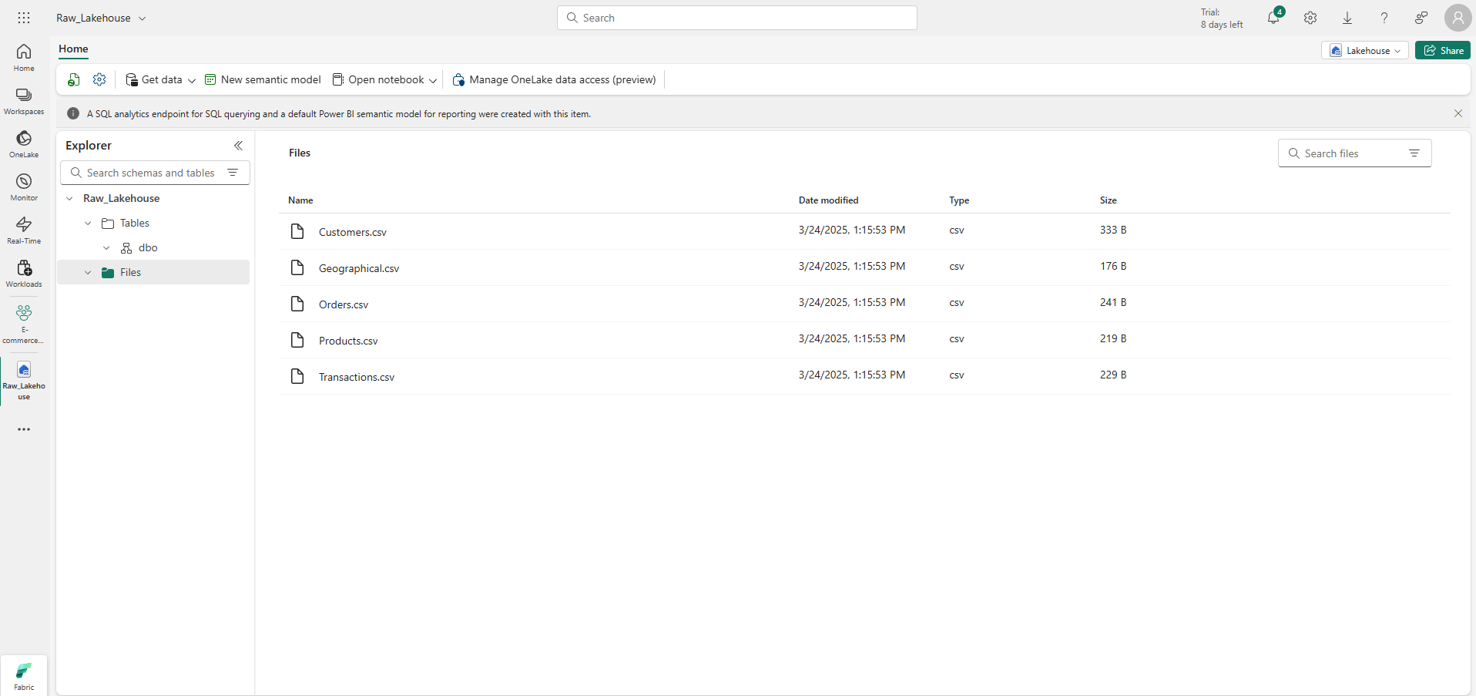

1. **Separate workspace for e-commerce silver layer**

1. **Load data from bronze to silver layer and want to load as tables not files Created a silver Lakehouse to store all the tables**

1. **Created a data pipeline to convert all csv files into tables**

1. **Get filenames from get meta data all files are present in array child items inside child items there is name property**

1. **Iterate through child items used foreach**

1. **Copied entire data from source to destination**

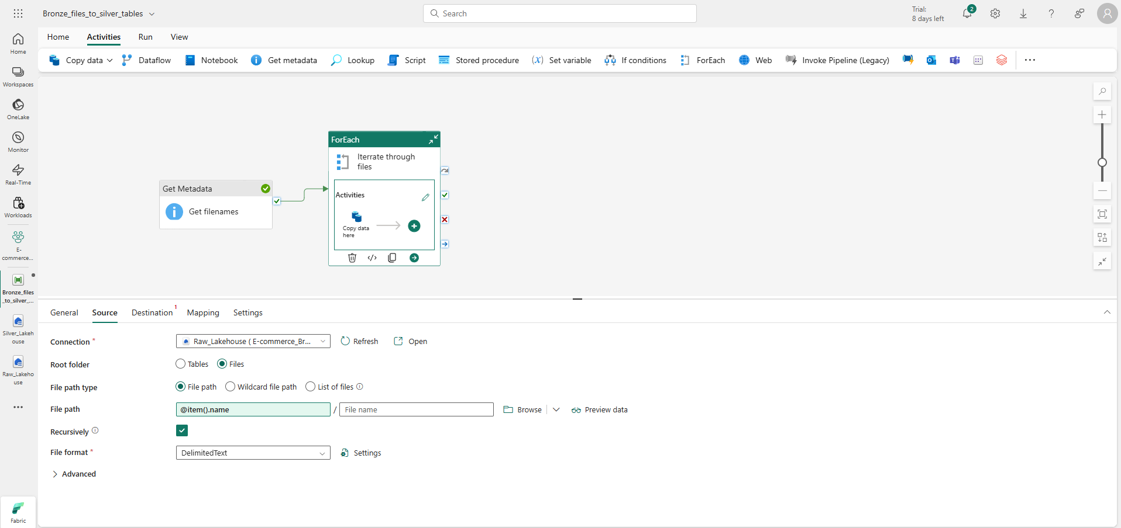

1. **The tables are present in silver Lakehouse**

1. **Now Need to do transformation on data can do this with dataflow gen 2 or Notebook all transformations happens on silver layer**

1. **Connect your Lakehouse**

1. **Connect spark session**

1. **Now doing transformations**

1. **In Golder layer we load data in warehouses because warehouses are more efficient for reading data as they are OLAP Systems**

1. **Now you want to load your cleaned and transformed data to this warehouse from silver layer**

**How will I bring my data?**

By dataflow gen2 why? Because of the golden layer and in this layer, we try to prefer things which are less technical so that noncoding users can also use this

1. **Load data from silver Lake house**

1. **This is a silver layer and want to load into the golden layer’s warehouse**

1. **Click on publish**

1. **Your data finally moves to the warehouse where all BI tools connect**

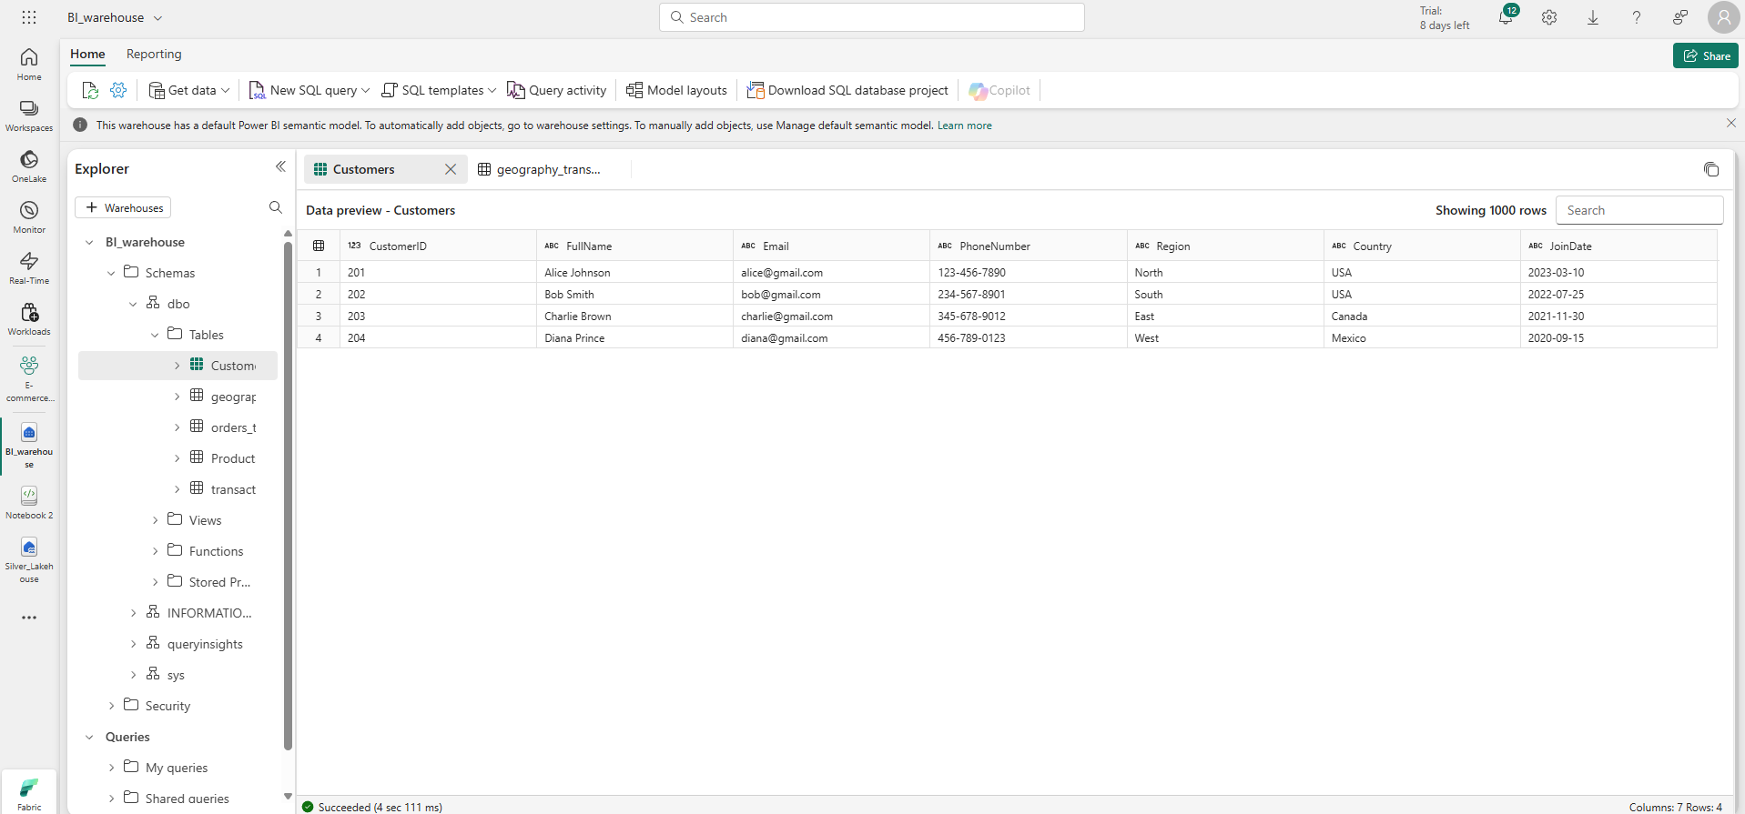

1. **Finally, to end, users create report**

1. **To give access**

1. **To schedule the refresh for all the data pipeline, dataflows and notebooks**

